**Project Design Phase-II**

**Technology Stack (Architecture & Stack)**

|  |  |
| --- | --- |
| Date | 20 June 2025 |
| Team ID | LTVIP2025TMID60795 |
| Project Name | Pattern Sense: Classifying Fabric Patterns Using Deep Learning |
| Maximum Marks | 4 Marks |

**Technical Architecture:**

The Deliverable shall include the architectural diagram as below and the information as per the table1 & table 2

**Example: Order processing during pandemics for offline mode**

Guidelines:

Include all the processes (As an application logic / Technology Block)

Provide infrastructural demarcation (Local / Cloud)

Indicate external interfaces (third party API’s etc.)

Indicate Data Storage components / services

Indicate interface to machine learning models (if applicable)

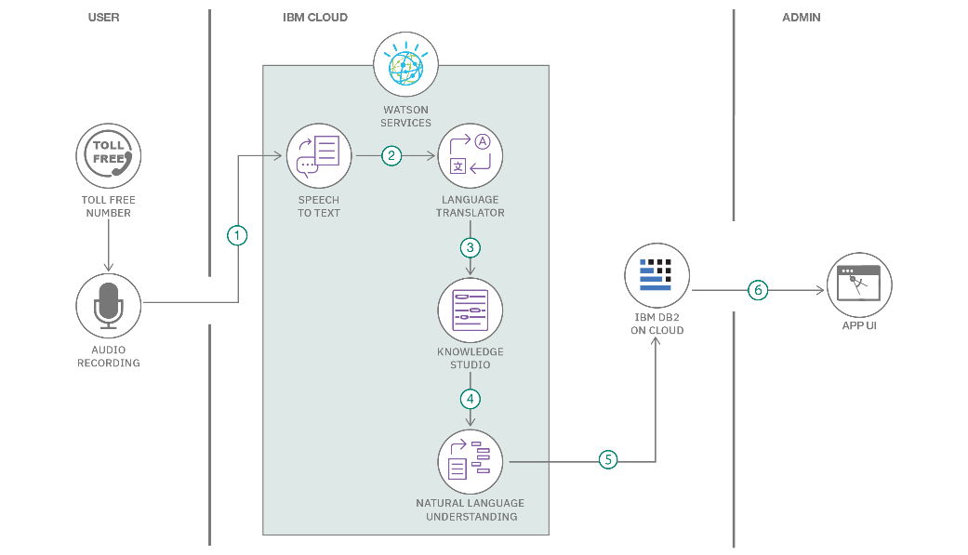

**Table-1 : Components & Technologies:**

|  |  |  |  |
| --- | --- | --- | --- |
| **S.No** | **Component** | **Description** | **Technology** |
| 1 | User Interface | Web interface for image upload and result display | HTML, CSS, JavaScript |
| 2 | Application Logic-1 | Image preprocessing (resize, normalize) | Python (OpenCV, NumPy) |
| 3 | Application Logic-2 | Pattern classification logic | TensorFlow / Keras |
| 4 | Database | Metadata and feedback storage | SQLite / MongoDB |
| 5 | File Storage | Storage of uploaded and processed images | Local Filesystem / AWS S3 |
| 6 | Machine Learning Model | Fabric pattern classification | CNN Model trained using TensorFlow |
| 7 | Infrastructure (Server / Cloud) | Model and UI deployment | Flask on Local / AWS EC2 |

**Table-2: Application Characteristics:**

| **S.No** | **Characteristics** | **Description** | **Technology** |
| --- | --- | --- | --- |
| 1 | Open-Source Frameworks | TensorFlow, Flask, OpenCV |  |
| 2 | Security Implementations | Image validation, basic auth, IAM on cloud |  |
| 3 | Scalable Architecture | Model server and UI can scale independently | Microservices on Docker/Kubernetes |
| 4 | Availability | Deployed on cloud with uptime guarantees | AWS EC2 with monitoring |
| 5 | Performance | Optimized model and API response under 3s | Flask + TensorFlow Lite + CDN |